

Receive up to $1200 *12 months 12.00%*APR
Special runs July 1, 2026 - September 30, 2026
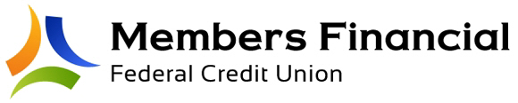
*APR = Annual Percentage Rate. All applicants subject to credit approval. Normal qualifications apply. Loan amount not to exceed $1200. Term and rate are as advertised and shall not differ from what is shown. Rate awarded will be 12%APR, no exceptions. No other offers can be combined with this promotion.

