Fall 2024 Newsletter

# A Message from our President

As a Member Financial Federal Credit Union Member, you can be confident that your credit union continues to maintain financial strength and stability due to our strong business model. MFFCU is a not-for-profit financial cooperative owned by you, our Members, and operating solely to serve the best interests of our Members and communities.

Unlike other financial institutions that have experienced large decreases in their earnings, we are not subject to pressures from investors or stockholders to grow large profits or to concentrate on any one industry or segment. Instead, we are able to make long-term decisions based on supporting the well-being of our Members instead of decisions being driven by short-term market fluctuations.

We focus on helping people save money and returning our earnings to our Members by offering greater value on savings, loans, and other financial services. This has a positive impact on the lives of our Members and communities and allows us to continue to grow in a sustainable way and help even more people.

In today’s challenging economy, it is more important than ever to do business with people and companies you trust. With our mission of serving the best interests of our Members and communities, MFFCU offers a better deal every day of the week- and we really shine in tough times, because we are committed to working with our Members to help find personalized solutions that meet their unique individual needs.

For all these reasons, we are here to listen and help you anytime- whether you are concerned about your finances, navigating life changes, or looking to save for the future. Our goal is to help you find solutions that will give you peace of mind. Let us know how we can help!

Thank you for your Membership,

Rebecca Wisdom  
President & CEO

# Breast Cancer Awareness Month - Awareness Days Events Calendar 2024Breast Cancer Awareness

The month of October is Breast Cancer Awareness Month and Members Financial Federal Credit Union is showing their support by wearing PINK on Fridays and raising money for Breast Cancer Research. Purchase a $20 ticket with a chance to win a PinkTober Breast Cancer Awareness Basket complete with high end gift items and gift cards. All proceeds will benefit the American Cancer Society of the Permian Basin. All monies collected will remain in the Basin!  
Driven by one of the founding principal philosophies, People helping People, MFFCU knew they had to get involved and help bring awareness to such an important topic.

# Take control and prevent fraud

### A cartoon of a person holding a credit card Description automatically generatedText messages and emails can be fraud, too.

Scammers can use the same spoofing tactics to send you text messages and emails impersonating someone or a business you know. These messages may include urgent requests, such as to verify transactions or confirm account information, and often include unsafe links or attachments. What should you do?

Don’t click that link- just hit delete.

If you receive a suspicious email, do not click any links or open any attachments. They may contain malware that can damage your computer or phone. You can always contact MFFCU directly if you are unsure if a text or email is legitimate.

It is important to remember: MFFCU will never contact you and ask you to confirm your digital banking username, password, card number, or six-digit verification code.

We are here to help you stay vigilant and protect your information and your hard earned money. If you have questions or think you may have been a victim of fraud, please report it to MFFCU at:

1 (800) 869-0961 or contact us online.

# Find Branches & ATMs | American United Federal Credit UnionNeed an ATM?

The CO-OP has you covered with nearly 30,000 surcharge-free CO-OP ATM locations nationwide, convenience is KEY. This surcharge FREE network of ATMs allows you to keep your cash in your pocket, where it counts.

* Aside from the thousands of Credit Union ATMs, you can get cash at many popular retail locations such as Walgreens, Costco, and DK stores.

Use your card at any ATM showing the CO-OP logo surcharge free.

# Enroll in eStatements today!

Did you know you can conveniently print your eStatements right from your online banking account, free of charge? Going paperless is not only sustainable, but it also keeps your account secure. Need assistance enrolling? Our Member Services department would be happy to help!  
Email [info@membersffcu.org](mailto:info@membersffcu.org) or call us at (432) 520-3443



# Moved recently?

Don’t forget to update your address! Make sure the Credit Union has your correct address on file because all returned mail will incur a $5 fee.

# A cell phone with a logo Description automatically generatedWe are everywhere you are with our MFFCU Mobile Banking App!

Access your accounts anytime by downloading our MFFCU Mobile Banking app from your smartphone app store.

* View balances and transfer funds
* View accounts, loans, statements, set-up alerts and Face ID
* Make loan and Mastercard payments
* Remote Deposit from ANYWHERE – ANYTIME

# What is a Home Equity Loan?

A home equity loan is a type of mortgage secured by the equity in your home. It offers a set amount at a fixed interest rate, so it is best for borrowers who know exactly how much money they need. You will receive the funds in a lump sum, then make regular monthly repayments amortized over the term of the loan, typically as long as 20 years.

* Home equity loans are best used for renovation or repair projects – which can make their interest tax-deductible or school expenses, vacations to consolidate other debts.

Because your home is the collateral of the loan, the amount you will be able to borrow is related to its current market value. The interest rate you receive on a home equity loan (as with other loans) will vary depending on your lender, credit score, income, and other factors.

# Holiday Skip-A-Pay

Need a break or extra money for the holidays? Participate in the loan payment skip for the months of November and December. Forms have been emailed to the members with current loans. Forms are also available on the website [www.membersffcu.org](http://www.membersffcu.org).

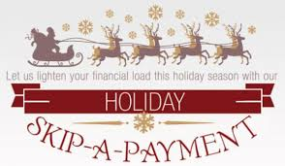**To be eligible for this offer, all Credit Union loans and accounts must be in good standing. Home Equity loans and Credit Cards are not eligible.**

## Eligible Loans:

* Auto loans
* Personal (Signature) loans
* Motorcycle Loans
* Toy Loans (RV, ATV, etc.)

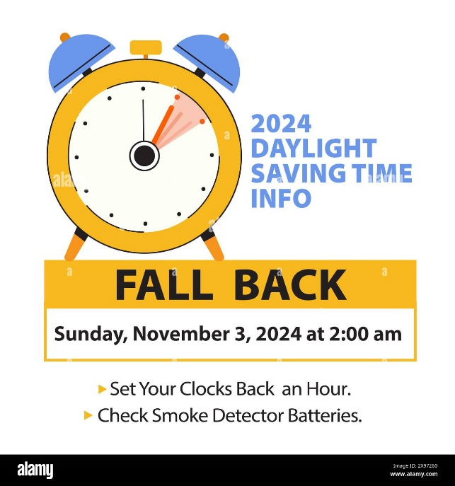



Credit Union Closures www.membersffcu.org

October 14th – Columbus Day Monday – Thursday – 8:30AM –5:30PM

November 11th – Veteran’s Day Friday - 8:30AM – 6PM

November 28th, 29th, & 30th – Thanksgiving Saturday – 9AM – 1PM Drive-Thru Only

December 24th & 25th – Christmas

