

**Spring 2024 Newsletter**

# A Message from Our President / CEO

This time of year, we welcome warmer air and increased opportunities to spend more time outdoors. Of course, that change comes with some seasonal allergies and, eventually, the “joy” of mosquitos. Those nuisances, however, are a small price to pay when you consider the good times that summer brings. At Members Financial FCU, we’re experiencing a season of change as we work to modernize your credit union, and we’re confident the benefits ahead will be worth the efforts. Those of you who utilized the website recently, experienced a change to a new and improved site providing easier navigation and more digital services. Using the improved credit union APP allows you to pay bills, transfer funds, mobile deposit checks, set-up alerts and check balances. The App is a timesaver for members. Another change coming April 1st is the launch of Business Checking accounts. From embarking on a new venture to expanding an existing business, help take your business where it needs to go. Choose from a variety of dividend earning options of Business Saving Accounts, Money Market Accounts, and CD Accounts. These accounts will grow your money and your business.

We’re looking forward to bringing more changes in the coming year. New credit and debit cards with added features and conveniences to the online and mobile banking services available to you.

The improvements we’re making are designed to enable us to serve you better. Thank you for being a MEMBER, and for your continued support of Members Financial FCU.

Sincerely,

Rebecca Wisdom

President/CEO



**Congratulations!**

**A big round of applause to all the upcoming 2024 graduates! We would like to congratulate all of you. Best wishes to all your future endeavors!**

Find us on Facebook

Members Financial FCU



Credit Union Closures www.membersffcu.org.

(800)869-0961 (432)520-3443

May 27th – Memorial Day Monday – Thursday – 8:30AM –5:30PM

JUne 19th – Juneteenth Friday - 8:30AM – 6PM

July 4th – 4th of July Saturday – 9AM – 1PM

**NOW AVAILABLE**

BUSINESS CHECKING ACCOUNTS

**Help take your BUSINESS where it needs to go!**

**From launching a new venture to expanding an existing business.**

**Introducing …Members Financial FCU Business checking accounts and Business interest bearing savings accounts, money market accounts and CD’s. Choose from a variety of these dividend earning options to grow your money and your business.**

**Did you know** that the U.S. Postal Service processes more than 158 billion pieces of mail in a fiscal year and 6.8 billion pieces (4.3%) are undeliverable! This could be your monthly statements... why not switch to e-Statements today, where you can securely retrieve at your convenience.

## **e-Statements**

e-Statements are a 100% free, convenient, and secure service that provides online access to your MFFCU account statements. Your e-Statements include all the same information as a paper statement, with the benefit of receiving it electronically. E-Statements are much safer than mailed paper statements and are completely secure when you access them through Digital Banking.

**Benefits of using e-Statements**

* Receive statements faster and safer than through regular mail.
* Save time and reduce paper clutter.
* View your statements in easy-to-read PDF format.
* Reduce the amount of private information in your mailbox that is susceptible to fraud and identity theft.
* 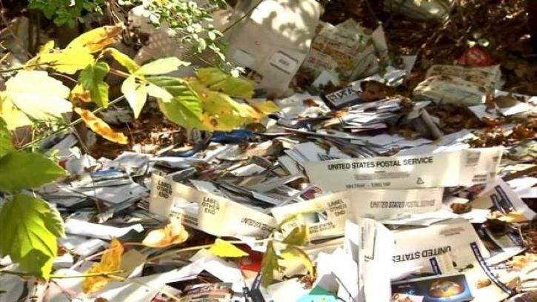Print your statement if ever a paper copy is needed. Your e-Statement can also be downloaded to your computer for future reference.

Shopping online?

Here’s what to do when things go wrong.

Ever had a bad online shopping experience? Maybe you ordered one thing but got another. Or that new company never shipped your order, despite charging you. So, what do you do? If you can relate, you’re not alone. In 2022, online shopping scams were the second-most reported type of scam to the FTC. The good news is you have rights, and there are steps you can take. If something didn’t arrive or you didn’t accept it, and now the company won’t refund your money, dispute the charges. If products show up that you never ordered, you don’t have to pay for them. Federal law protects you. To try to stay ahead of these problems, if you haven’t shopped with a company before, start by searching online for the company’s name, plus words like “review,” “complaint” or “scam.” See what other people are saying. **And no** **matter where you shop online,**

**REMEMBER:**

• Check refund and return policies. Sellers often have different refund and return policies for sale items, and dishonest sellers will use ­ne print to deny refunds. Use a credit card for online purchases, if possible. Credit cards offer the most protection against fraud compared to other types of payments, including the right to dispute charges if there are problems with your purchase. Always save receipts and confirmation emails. If something goes wrong, these can Help you get your money back from the seller or file a dispute with your credit card company.

**If you suspect a scam, report it to the FTC** **at ReportFraud.FTC.gov**.

**SPRING HAS SPRUNG**

**Unlock Your Home’s**

**Potential With a**

**Fixed-Rate**

**Home Equity Loan**

**Take a trip, complete home projects, pay off bills. It is endless what you can do once you get a Home Equity loan. Apply today and use your home’s equity to achieve your wishes.**

