Summer 2024 Newsletter

**The TEMPERATURES are going up and so are our Dividend and Money Market Rates. Come SAVE WITH US!**

**CD RATES**

**1K -9,999K 13 Months 3.00%**

**18 Months 3.25%**

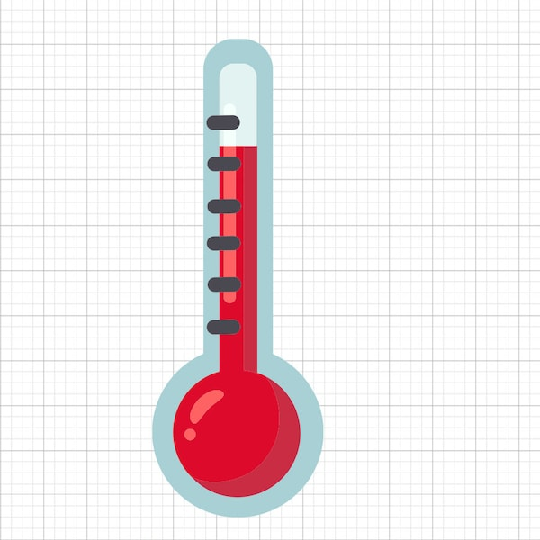 **25 Months 3.50%**

**10K – 49,999 13 Months 4.00%**

**18 Months 4.25%**

**25 Months 4.50%**

**50K Plus SPECIAL 13 Months 5.10%**

**Money Market**

**Up to 5K 2.00%**

**Up to 30K 3.00%**

**30K+ 4.00%**

**3100 Sunburst Dr., Midland, TX 79707 Phone (432)520-3443**

6 Ways to Tell if a website is Safe

1. **Look for an SSL certificate**

Secure websites have an SSL, or a Secure Sockets Layer. An SSL is a digital certificate that verifies a website is authentic and will automatically encrypt all personal information and financial data. There are two primary indicators of an SSL, and both are clearly visible in the site’s URL:

* An ‘s’ after the ‘http’
* A padlock icon

1. **Evaluate the URL structure**

Review the URL carefully. Are there misspelled words? Does the URL mimic a well-known site? Scammers often lure victims by creating bogus sites that look like they represent well-known companies. However scrutiny of the URL will reveal basic spelling errors that give the scam away.

1. **Look for the company’s contact info**

Legitimate companies are eager to have you connect with them for any reason. They’ll generally display their contact info on their home page or provide a link for easy access. Scammers, on the other hand, try to keep themselves as invisible as possible. You likely won’t find any tabs that say “Contact Us” or “About Us” on their website.

1. **Check the spelling and graphics**

Authentic companies will take the necessary steps to make a professional impression on site visitors. Scammers, on the other hand, will not. Use their carelessness to your advantage by looking out for spelling mistakes and typos throughout the site. You can also be on the lookout for cheap design elements, including recycled images and logos that are poorly created. Each of these clues can signify a scam website.**Heed your device’s security warnings**

If you put a site’s address into your computer, and a warning pops up alerting you that the site you’re attempting to access is unsafe, don’t ignore it. Unless you’re sure the site is secure despite the warning, it’s best to not advance to the site.

1. **Opt out of sites that flood you with pop-ups**

Scam websites will try luring you into downloading malware through pop-ups and embedded links. Sometimes, the links will be used to generate ad revenue through clicks. Whatever the intent, it’s important to know that reputable sites will not flood your screen with pop-ups and random links for you to click. If you encounter a site like this, you’re likely looking at a scam. Exit the site, close your browser and have your security system run a scan on your device.

**Stay alert online and stay safe!**

Choose a Business Checking Account at Members Financial Federal Credit Union because…

* We often charge fewer fees than traditional banks.
* You will earn better interest rates on deposits.
* You must become a credit union member to open a credit union business account.
* Access to Debit cards, MasterCard and online banking.
* ACH, wire transfers, mobile check deposits and cash withdrawals

A business checking account is a secure place to store your company’s cash as payments go out and come in. Anyone who owns a business should have a business checking account. That includes LLC’S, as well as sole proprietors.

**All-in-one platform**

|  |  |
| --- | --- |
| A picture containing email  Description automatically generatedEaster Holiday Office & Waste Sites Closures - Municipality of Huron Shores  Credit Union Closures www.membersffcu.org.  (800)869-0961 (432)520-3443  July 4th – Fourth of July Monday – Thursday – 8:30AM –5:30PM  September 2nd – Labor Day Friday - 8:30AM – 6PM  Saturday – 9AM – 1PM  Find us on Facebook  Members Financial FCU   |  | | --- | |   **MOBILE DEPOSIT**  Utilize the Members FFCU mobile app to make deposits from your phone to your checking account. Deposit checks in a few taps.  **Take Care of These Money Factors Before You Travel** | |
| |  | | --- | | You made your travel budget, saved your money, and made your reservations. You’re ready to set off on your next great adventure. But have you prepared your home finances to continue worry-free while you’re gone? Do you have all the information you need to manage your travel budget while you’re away? Here’s a checklist you can use to be sure you are prepared. | |
| |  | | --- | | **TRAVEL TIPS** | |
| |  | | --- | | **Banking Essentials**   * **Pay upcoming bills.**While you’re on vacation, you want to relax and not worry about anything. Even if your bills are due the day you get back, it is best to pay them before you leave or set up [**automatic payments**](https://www.wealthcu.org/how-to-videos#bill-pay). You may be tired when you come home, and it could take some time to get unpacked and reacclimatized to home life. In the interim, you don’t want to miss a payment. * **Notify your credit card company.**Nothing is worse than attempting to use your credit card while on vacation and having it denied. Credit card companies take security very seriously, so a charge on your card from a place where you’ve never been before could trigger the credit card’s fraud system. To make sure credit card transactions are seamless in any location, contact your credit card company before you leave home and tell them about your plans to travel. * **Notify the credit union** to put a travel advisory on your debit card.   Preparation is the key to any activity; travel is no exception. Remember to manage these money moves before you leave on your next vacation, and you will be ready to enjoy a relaxing trip  The Year in Review: U.S. Tourism During 2016 - InDepthNH.orgInDepthNH.org | |

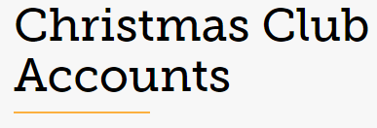

Start saving now for a stress-free holiday season with a 2.00% APR* dividend rate on a Christmas Club Account. Make this Christmas merry and bright!

Open with $100, deposit through the end of October. Check will be mailed out on November 1st after dividend pays. Account stays open to start depositing for next year.

Open an account by July 15th and your name will be placed in a drawing for $100 at the end of October.

$10 fee for early withdrawal.

The sooner you start saving, the more money you’ll have for gifts, decorations, and all the holiday cheer you can handle!

**KIDS CORNER**

A GOOD …FINANCIAL MOVE

**Happiness begins with a SUMMER LOAN**!

**Apply today… no waiting, deposited into your checking account at Members Financial FCU.**

**Easy start to SUMMER fun.**

**Borrow up to $1200 for 12 months as low as 9.25% APR* Annual Percentage Rate**

**June 1 – July 31 Some restrictions apply.**

